**Topics: Descriptive Statistics and Probability**

1. Look at the data given below. Plot the data, find the outliers and find out $μ,σ,σ^{2}$

|  |  |
| --- | --- |
| **Name of company** | **Measure X** |
| Allied Signal | 24.23% |
| Bankers Trust | 25.53% |
| General Mills | 25.41% |
| ITT Industries | 24.14% |
| J.P.Morgan & Co. | 29.62% |
| Lehman Brothers | 28.25% |
| Marriott | 25.81% |
| MCI | 24.39% |
| Merrill Lynch | 40.26% |
| Microsoft | 32.95% |
| Morgan Stanley | 91.36% |
| Sun Microsystems | 25.99% |
| Travelers | 39.42% |
| US Airways | 26.71% |
| Warner-Lambert | 35.00% |

Answer:-

|  |  |
| --- | --- |
| Mean | 33.27 |
| Variance | 287.146612380952 |
| Standard Deviation | 16.945400921222 |
| Outliers | 91.36 |

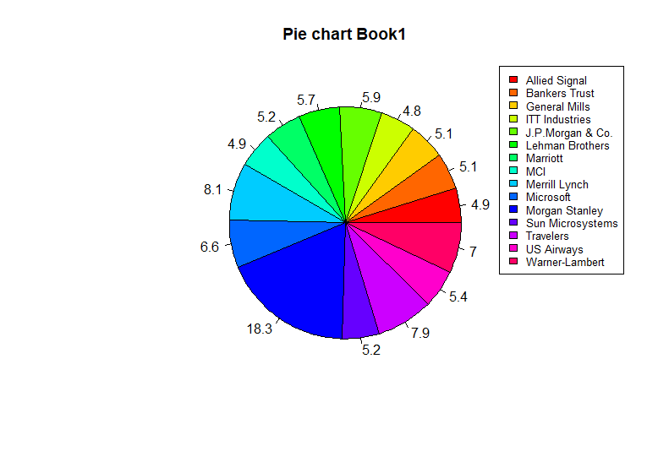

CODE:-

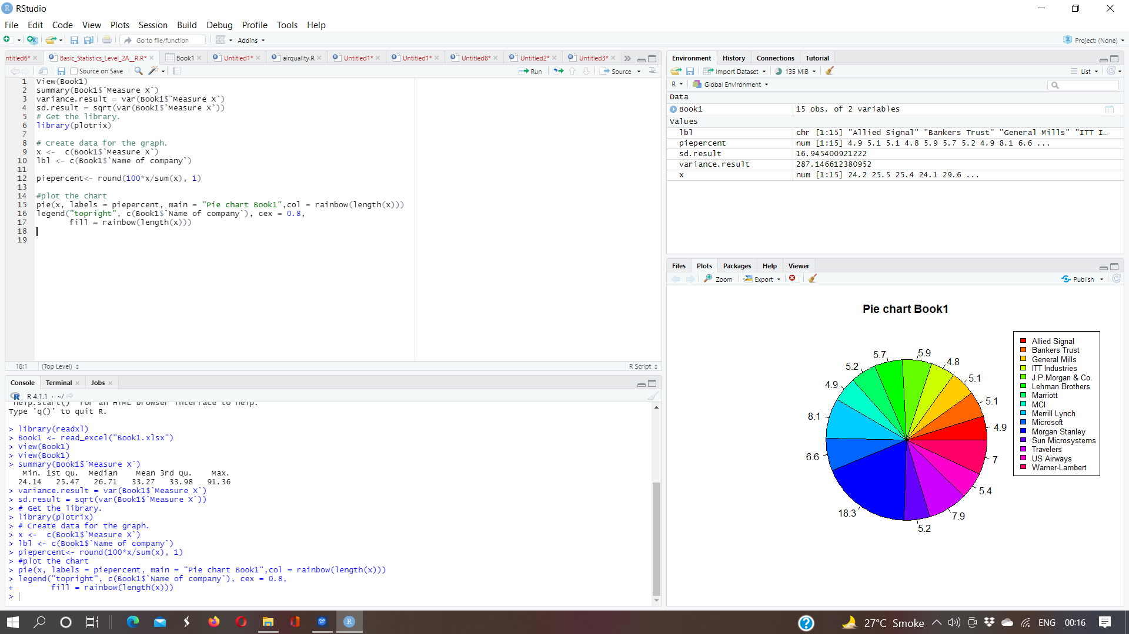

1. Answer the following three questions based on the box-plot above.



1. What is inter-quartile range of this dataset? (please approximate the numbers) In one line, explain what this value implies.
2. What can we say about the skewness of this dataset?
3. If it was found that the data point with the value 25 is actually 2.5, how would the new box-plot be affected?

Answer:-

1. upper IQR =1.5+(12-5) =8.5

Lower IQR = 1.5-(12-5) =6.5

1. It is a positive skewness because the data is present on right side
2. there will be no outlier
3. Answer the following three questions based on the histogram above.



1. Where would the mode of this dataset lie?
2. Comment on the skewness of the dataset.
3. Suppose that the above histogram and the box-plot in question 2 are plotted for the same dataset. Explain how these graphs complement each other in providing information about any dataset.

Answer:-

1. The Mode of this dataset lie in between 4 to 8
2. The skewness of the dataset is positive skewness beacuse its tail on the right side.
3. Histogram is used to find out mode, skewness, kurtosis and boxplot is used to find out IQR and outliers.
4. AT&T was running commercials in 1990 aimed at luring back customers who had switched to one of the other long-distance phone service providers. One such commercial shows a businessman trying to reach Phoenix and mistakenly getting Fiji, where a half-naked native on a beach responds incomprehensibly in Polynesian. When asked about this advertisement, AT&T admitted that the portrayed incident did not actually take place but added that this was an enactment of something that “could happen.” Suppose that one in 200 long-distance telephone calls is misdirected. What is the probability that at least one in five attempted telephone calls reaches the wrong number? (Assume independence of attempts.)

Answer:-

The total no. Of calls 200

One wrong no. Out of 200

Probability of wrong number = 1\200 = 0.005

Probability of not wrong number = 1-0.005

=0.995

Probability of atleast one out of five is a wrong number

= 1 – probability of atleast one out of five calls are not wrong numbers

= 1 – (1 – 0.005)^5

= 1 – 0.975

= 0.024

= 2.5%

1. Returns on a certain business venture, to the nearest $1,000, are known to follow the following probability distribution

|  |  |
| --- | --- |
| x | P(x) |
| -2,000 | 0.1 |
| -1,000 | 0.1 |
| 0 | 0.2 |
| 1000 | 0.2 |
| 2000 | 0.3 |
| 3000 | 0.1 |

1. What is the most likely monetary outcome of the business venture?
2. Is the venture likely to be successful? Explain
3. What is the long-term average earning of business ventures of this kind? Explain
4. What is the good measure of the risk involved in a venture of this kind? Compute this measure

Anwer:-

1. The most likely monetary outcome of the business venture is 0.3
2. yes the venture likely to be successful p(x=1000)+p(x=2000)+p(x=3000)=0.2+0.3+0.1=0.6
3. The long-term average earning of business venture is

(0.1)(-2000)+(0.1)(-1000)+(0.2)(0)+(0.2)(1000)+(0.3)(2000)+(0.1)(3000)= 800

1. The good measure of the risk involved in a venture of this kind is standard deviation.